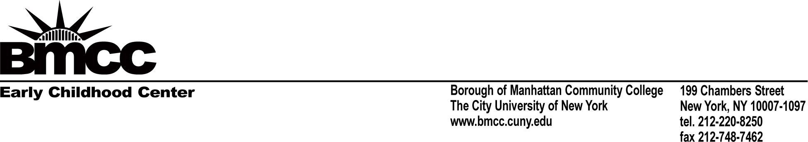

The Early Childhood Center at BMCC is a not for profit supported by a mix of city, state and federal funding. Due to this blended funding model our program has been able to ensure that out of pocket costs for student parents is kept to a minimum. The support and generosity of our funding partners has allowed our program to provide hybrid services to children and families.

The program is funded by Child Care Access Means Parents in School (CCAMPIS), Child Care Development Block Grant (CCDBG), City Council, Department of Education, BMCC Student Activities and our newest funding support, the Family Empowerment Program Grant (FEP). FEP grant funding allows the program to continue to advance our support to the student parent community and continue to work with partners on and off campus to provide the highest level of support to our student parents. This includes but is not limited to; childcare, tutoring referrals, support with accessing the on-campus food pantry, assistance with offsite childcare, DOE funded programs, work study placement, linking students to the counseling center, support with navigating and accessing academic advisement, and registration support.

For more information about the Center and program offerings, please follow the links below:

BMCC ECC Website:
https://www.bmcc.cuny.edu/student-affairs/ecc/
Facebook: bmcc ecc
https://www.facebook.com/profile.php?id=100008916105073
Instagram: bmcc_ecc

