

Office of Public Affairs  
Fall 2022



Digital Style Guide

**Web Content**

Write for your audience 3

Web vs. print content 4

Avoid duplication of content 5

Paragraphs and subheads 6

Right column on webpage 7

**Formatting and Style**

Use of bold, underling and all caps 8

AP Style 9

Hyperlinks 10

Buttons 11

Use of color 11

Images 12

Logos 12

Accessibility 13

**Templates**

Academic Departments 14

Success Programs 15

Calendar Entries 17

Public Affairs Contacts 18

**Web Content**

**Write for Your Audience**

It is imperative that our web content is easily understood by a wide audience varying in age, education level, and native language.

**Who is your audienc**e?

* Current students
* Potential students
* Foreign students
* Returning or older adult students
* Disabled students
* Faculty
* Staff
* General community

**Plain Language**

Plain Language was developed to make sure written material is easy to understand for everyone. Many students and potential students are from other countries or may have limited formal education.

Some examples of plain language:

* Use short words instead of long ones. If you find yourself using a 4 syllable word, look for an alternative.

Ex. The XYZ Department prepares students who have various levels of proficiency to reach an optimum level of performance.

*Simplify this to*:

The XYZ Department helps students of all levels master the material.

**Reference for Plain Language**

Learn more about plain language at https://www.plainlanguage.gov/

**Web vs. Print Content**

When people look for information online, they want to be able to find what they are looking for quickly, without a lot of filler material. Studies show people tend to skim and scan websites for information, rather than read every word.

**Create Pages that are Easy to Skim and Scan**

People skim and scan web material, often on a cell phone. Try to get to the point in as few words as possible. Keep sentences and paragraphs short.

**Break Up Text**

Instead of large blocks of text, try to pare it down and then break up into separate paragraphs and where appropriate, bulleted lists.

**Use Headings and Subtitles**

People skimming a webpage will be able to see at a glance what topics are covered on a page. Subtitles are also helpful for search engine optimization, i.e. people doing Google searches for the topic you are discussing.

**Avoid Acronyms**

BMCC faculty and staff become familiar with our many acronyms. The new or potential student will not know what they mean. Plus, anyone searching for information on a topic will not find our site if crucial words are hidden in acronyms. Write out terms instead of using acronyms.

Ex. The School Health Education major is sometimes referred to by the acronym SHE.

*Instead of*, “The SHE major will lead to many career options.”

*Use*: “The School Health Education major will lead to many career options.

**Acronyms hinder Google Searches**

People searching for a course in education, for instance, will not find a page that uses, “SHE” instead of “School Health Education.”

Using the keywords “school health education” will help potential students who are Googling for programs find ours. It will also make our content more readable and user friendly.

**Avoid Duplication of Content**

**Duplication of Content**

We try to avoid having the same content in several places on the website. It is better to link to the content already in existence on another part of the website than copy it onto your webpage.

**Ex. Student Resources**: if you wish to include information about BMCC resources for students on your webpages, link to the Student Hub rather than re-listing individual services on your webpages.

**Ex. PDFs**: If you have a PDF booklet attached to your site, do not excerpt and repeat information from the PDF on the webpages.   
  
*However*, it is preferable to have information on the webpages *instead* of having viewers take the extra step of opening a PDF. The information is easier to find and creates a better viewer experience.

**Ex. Information from other websites**: Hyperlink to the other website *instead* of copying their material to ours. That way, when the other website updates their material, people will have the more current and correct information.

**Paragraphs**

Paragraphs should be relatively short and easy to read. There is rarely a need for a subtitle over the first paragraph on a page—skip the subtitle and go right into the topic. Paragraphs further down on the page can have subtitles.

**Use Keywords**

The first paragraph on a page should contain some keywords about the page topic, especially the first sentence. This will help with search engine optimization (SEO), i.e. your page coming up in relevant searches.

**Headings and Subheads**

**Headings should be:**

* To the point
* Preferably one line
* No acronyms

**Use Subheads**

* When a page has several paragraphs, subheads help the reader see at a glance what is on the page
* Subheads are also useful for search engine optimization

**Right column on a webpage**

The right column on the page is generally reserved for contact information and links to news and events. Not every page needs this information, but it is important to have consistency so viewers know what to expect. Information other than contact, news and events, can be placed in the center column.

For example, videos and images should be sized appropriately to go in the center column rather than the narrow right column. Many students will be viewing the site on a cell phone and may not even get to any videos or photos in the right column.

For example, here is the right column for the Women’s Resource Center (WRC) landing page. Some departments include a contact name, for instance, the program director, in the contact box.

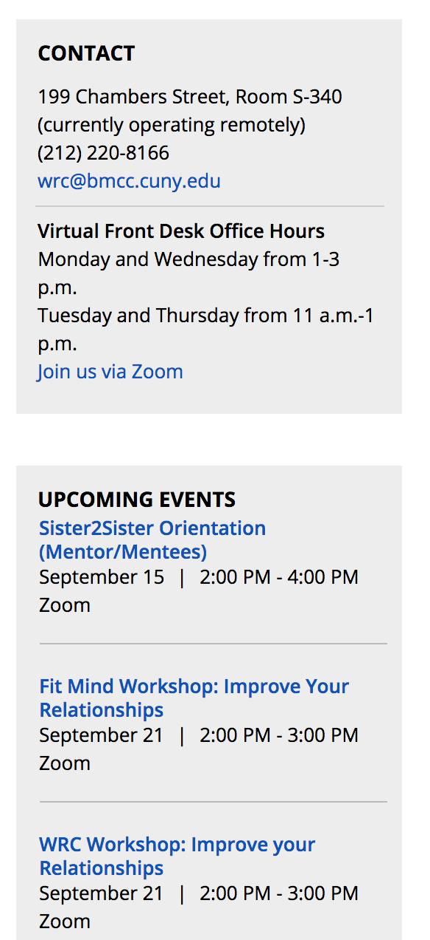

**Formatting and Style**

Consistent formatting and style give the website a cohesive look and help the viewer navigate through the material.

**Use of Bold Type**

Use occasional bold type to emphasize **one** or **two words**, not a whole sentence or paragraph.

**Use of ALL CAPS**

This is not a style we use on the BMCC website. It is more difficult to read than mixed case.

**Use of Underlining**

Underlining is not used on our website, because it can easily be mistaken for a hyperlink.

**Use of Colored Type**

Black type on a white background is the most easily read and that is the style we use. We use color in other ways, such as our banners and other graphics.

**AP Style**

BMCC makes use of Associate Press (AP) style for print and website. Using a particular style provides consistency and clarity for a website, as well as print materials.

Using the correct style (here a.m.) throughout the website makes the information that is important and different (i.e. the actual time: **4** p.m., **9** a.m.) stand out.

Some examples of AP style are:

**Time**

AP style uses periods for a.m. and p.m. and lower-case letters.

Ex. 3:30 p.m. or 8 a.m. is correct

**Dates, Months, Years, Days of the Week**

For dates and years, use figures. Do not use st, nd, rd, or th with dates

Ex. May 12 is correct . . . not May 12th

**Technological Terms**Here are the correct spellings for some common technological terms:

* e-book
* e-book reader
* e-reader
* email
* cellphone
* Facebook

**Numbers**Spell out numbers used at the beginning of a sentence. Exception:

Never spell out years.

Ex. Two hundred students volunteered for the program

2018 was the year the college president stepped down.

A good overview the AP style can be found at the following:

* The [Purdue Online Writing Lab](https://owl.purdue.edu/owl/subject_specific_writing/journalism_and_journalistic_writing/ap_style.html) (<https://owl.purdue.edu/owl/subject_specific_writing/journalism_and_journalistic_writing/ap_style.html>)

**Hyperlinks**

**Use hyperlinks sparingly**

Hyperlinks stand out on a page and too many hyperlinks will distract the viewer. You want to call attention to the few hyperlinks that are most important.

**Hyperlink words instead of using naked links**

* BMCC is having an Open House on November 4:   
  <http://www.bmcc.cuny.edu/calendar/events.jsp?id=29697>

*Should be written as:*

* BMCC is having an [Open House](http://www.bmcc.cuny.edu/calendar/events.jsp?id=29697) on November 4.  
    
  This format is not only easier for the viewer to read, it helps in search engine optimization.

**Avoid “click here”**

* BMMC is having an open house on October 13. [Click here](http://www.bmcc.cuny.edu/calendar/events.jsp?id=29697) to learn more about the open house. [Click here](http://www.bmcc.cuny.edu/calendar/events.jsp?id=29697) to learn more about the Borough of Manhattan Community College. To register for the event [click here](http://www.bmcc.cuny.edu/admissions/openhouse/).

*Should be written as:*

* BMMC is having an open house on October 13.   
  Learn more about BMCC. You can [register](http://www.bmcc.cuny.edu/admissions/openhouse/) online   
  for the event.  
    
  This format as well is easier for the viewer to read and helps in search engine optimization.

**Linking to a pdf**

* If a link goes to a pdf indicate that, i.e. link (pdf)

**Buttons**

Buttons should be used occasionally—generally for a call to action such as an “Apply Now” or “Contact Us” hyperlink. We have a specific style of button that we can set up for you.



**Use of Color**

The BMCC website has been set up with font types, sizes and colors that are part of our style. For web and calendar entries, we use black type on a white background, which is easy to read.

Headlines are preset in different sizes of black type.

If you do create documents that will be attached to a webpage or calendar entry, here are some things to consider:

**Consider Contrast**

Color choice in type or graphics is an accessibility issue, as high contrast (for instance black type on white background) is the most easily visible.

**Limit color**

Less is more in web color choices. Use of color should be consistent with the web style, in this case, black type on white background and occasional use of blue and orange (the school’s colors).

**Avoid blue type** because blue is frequently used to denote hyperlink text. Viewers are tempted to click on blue type when they see it.

**Images**

We prefer to use images of real BMCC students enjoying their college experience. That is part of our branding and makes us unique among many websites that use stock images. Do not use clip art, flyers or graphics copied from other websites for calendar entries or webpages.

The Office of Public Affairs provides images for calendar entries and web pages, taken by our on-staff professional photographer. Consult with the Office of Public Affairs about appropriate images for web and calendar pages.

If you do create documents that will be attached to a webpage or calendar entry, here are some things to consider:

* You must have legal right to use an image—cannot just copy from other websites.
* Public domain images can be used.

**Image Sizes**

Photo sizes used on the website and web calendar are standardized as follows. We will crop and resize photos as necessary:

* web page banner: 1140 x 400 pixels
* calendar entry banner: 830 x 350 pixels
* headshots: 4x5 ratio, generally 120 x 150 pixels

**Note**: We provide images taken by our staff photographer in the WordPress Media Library, already sized for like calendar events, etc. Each department or office has it’s own folder where we can add photos.

**Logos**

We use the BMCC logo throughout the site. We do not post logos of individual programs or external organizations.

**Accessibility**

The City University of New York (CUNY) is committed to providing students, faculty, staff, and the general public with the technology and information they need, and to making these resources accessible to all, in accordance with [CUNY’s Policy on Equal Opportunity and Non-Discrimination](http://www2.cuny.edu/wp-content/uploads/sites/4/page-assets/about/administration/offices/hr/policies-and-procedures/CUNYPolicy-Equal-Opportunity-and-Non-Discrimination-010115-procedures.pdf) and applicable law. See CUNY's [IT Accessibility Statement](http://www2.cuny.edu/accessibility/statement/) for more information.

Anyone developing content (text, images, video, etc.) for online publications or systems should ensure that all the necessary elements are provided to make the content accessible to people with disabilities, including blind, low vision, deaf, and hard of hearing users.

**PDFs**

* For attached or linked PDFs to be accessible, you should be able to select the text with a mouse (a screen reading device will then be able to read it).
* For more information, see CUNY’s [Creating Accessible PDF and Microsoft Office Documents](http://www2.cuny.edu/accessibility/content/pdf-microsoft/).

**Videos**

* Include closed captions or transcripts for any audio or video elements.
* For more information, see CUNY’s [Captioning Videos](http://www2.cuny.edu/accessibility/content/videos/).

**General**

* All documents should have descriptive titles.
* Sans serif fonts such as Arial, Helvetica or Verdana work best on screens. Use 12 point or larger.
* Be cautious as to the colors you choose. Some colors and color combinations can be difficult to read, especially for someone who has color blindness. Provide sufficient color contrast.
* Use descriptive hypertext links.
* If a link goes to a pdf indicate that, i.e. link (pdf)
* Use bulleted and numeric lists for related items.
* See CUNY’s [Making Content Accessible](http://www2.cuny.edu/accessibility/content/) page for more information.

**Academic Department Webpage Format**

Here is an example of the style and format we are using for academic departments.

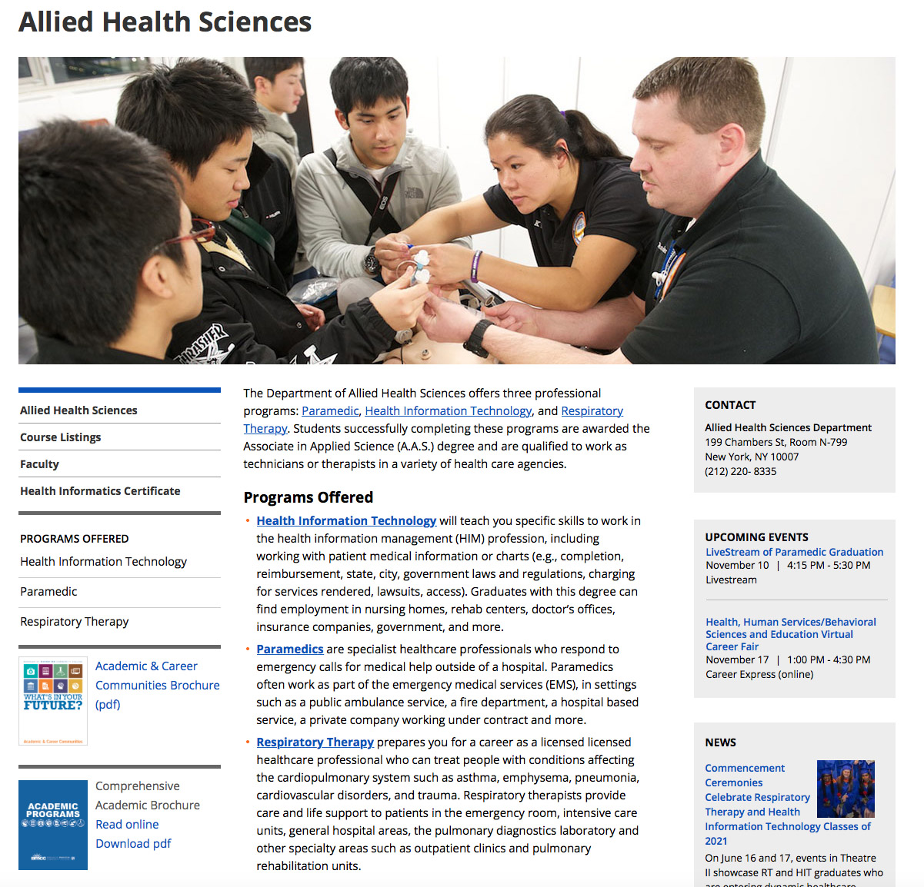

**Use Keywords in Introductory Sentence and Paragraph**

“The Department of Allied Health Sciences offers three professional programs: [Paramedic](https://www.bmcc.cuny.edu/academics/departments/allied-health/paramedic/), [Health Information Technology](https://www.bmcc.cuny.edu/academics/departments/allied-health/about-hit/health-information-technology-program-requirements/), and [Respiratory Therapy](https://www.bmcc.cuny.edu/academics/departments/allied-health/respiratory-therapy/). Students successfully completing these programs are awarded the Associate in Applied Science (A.A.S.) degree and are qualified to work as technicians or therapists in a variety of health care agencies.

The highlighted words are terms that potential students might search for on the internet.

**Success Program Format**

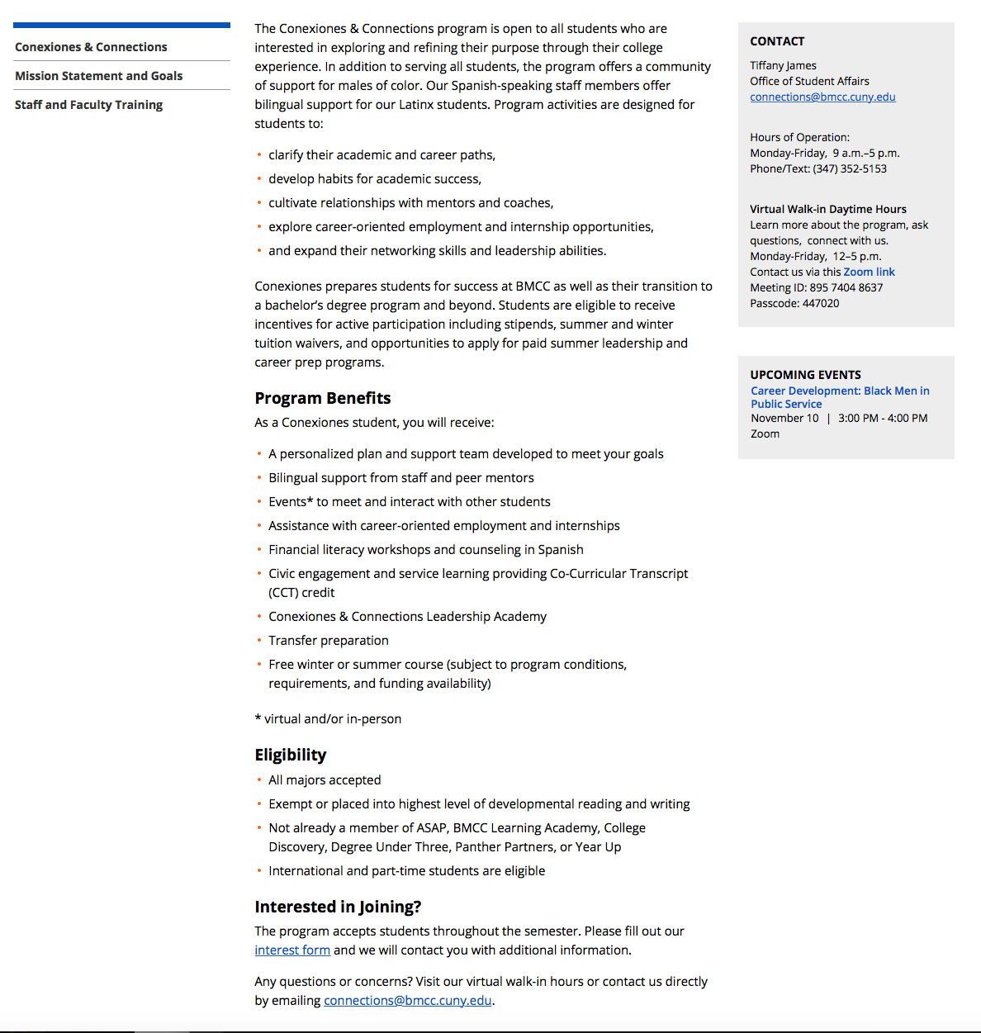

**Brief Description of Program:** A short (50-75 word) paragraph describing the program.

**Benefits:** A bullet list of the benefits your program offers to students.

**Eligibility Requirements:** What are the requirements for a student to apply to the program.

**Call to Action/How to Apply:** Link to an application or interest form. Mention whom to contact to apply for the program or for more information. State any relevant deadlines.

**Calendar Entries**

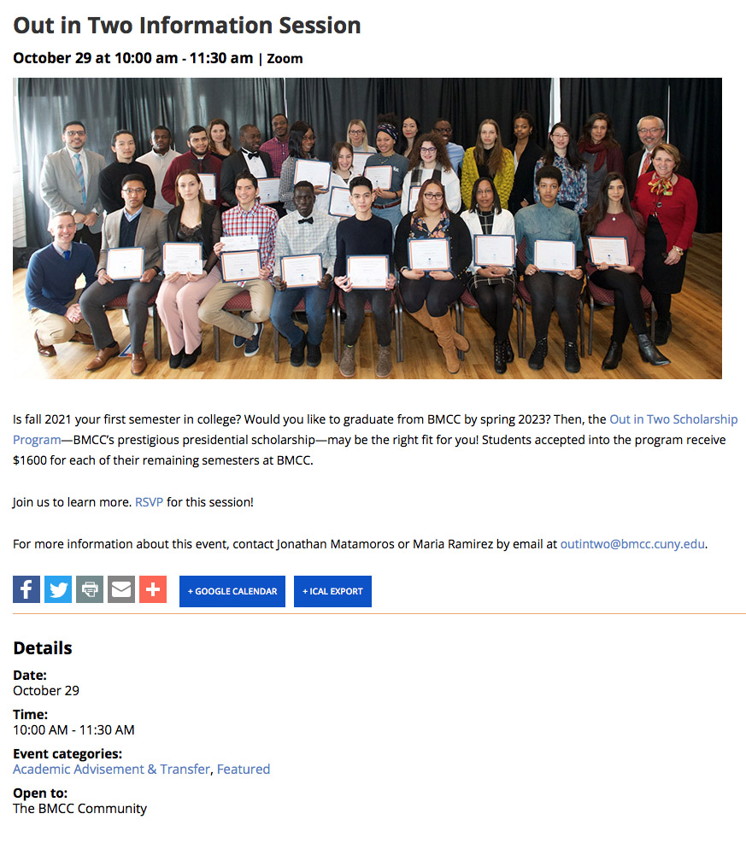

**Calendar entries should contain:**

**Short Description of Event:** 50 to 75 words. You can hyperlink to further information.

**Images of similar event in past—not a flyer or clip art**The Office of Public Affairs provides images for most calendar entries. We try to use photos of real BMCC students involved in classes and activities.

**Calendar entries, continued**

**Location: building, room or Zoom**

State which building the event is in, then the room number. For example:

* Fiterman Hall, room F-306
* 199 Chambers St.., room S-402
* Zoom

**Who can attend the event?**

We generally post events that are either:

* Open to BMCC community
* Open to the BMCC community and other CUNY schools
* Open to the general public

Note: If an event is for members of one department or program only, it would not be appropriate for the web calendar.

**Contact Information**

There should be a name and email and/or phone number to contact for more information. Include a hyperlink to the department or office sponsoring the event.

Since the web calendar is part of our public facing website, we don’t post events on the calendar that are just for a single department or program. Events must be open to all BMCC students.

**Office of Public Affairs**

**Main Number**: (212) 346-8501   
**Email**: publicaffairs@bmcc.cuny.edu

Samantha Ramirez, *Office Assistant*

### Web and Multimedia

Cynthia Blayer, *Web Content Manager*    
Rob Gizis, *Graphic and Multimedia Design*

### Publications

Tom Volpe, *Director of Publications*  
Sharmela Bhagwant, *Graphic Designer*  
Jeff Wong, *Graphic Designer*

### Marketing

Rosslynn Pieters, *Associate Director of Marketing*  
Louis Chan, *Photographer/Social Media Coordinator*  
David Pangburn, *Videographer*Mike Buri*, College Assistant*

### Public Relations

Lynn McGee, *Communications Manager*  
John Cody Lyon, *Writer*