Faculty Page
Guide

Office of Public Affairs
Updated 11/1/23
WordPress Content Management System

Welcome to our new WordPress Content Management System, which will make editing and managing your faculty page much easier. Please contact Public Affairs by phone (212) 346-8501 or email publicaffairs@bmcc.cuny.edu if you have any questions.

1) Go to Faculty/Staff Resources, a menu title towards the top of the BMCC website; select Faculty/Staff Resources on that menu

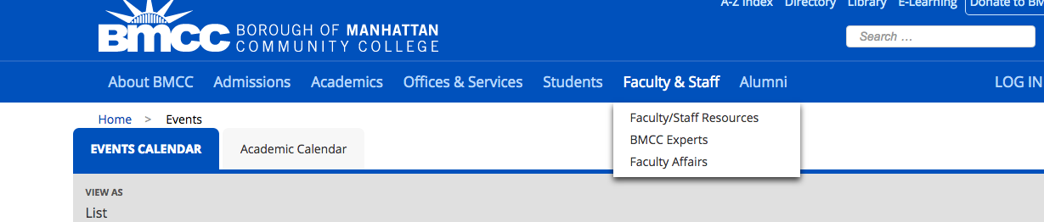

2) In the right column (Resources) scroll down to Faculty Page Log in.

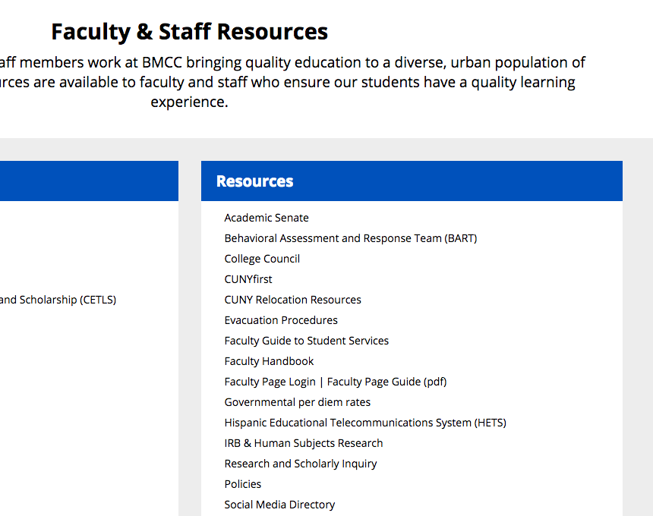
3) Log in to your faculty page with your Outlook email username password.

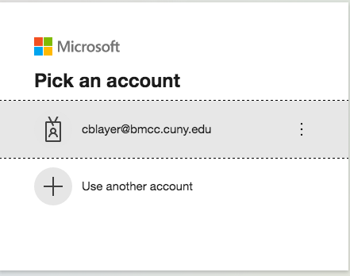

4) You will see your faculty profile from the backend of the site—the information here comes from CUNYFirst. If anything is incorrect on this page, we will report it to them.

To go to your faculty page, hover over the word “Faculty” on the left hand menu and then select “All Faculty”. (You will be brought directly to your faculty page)
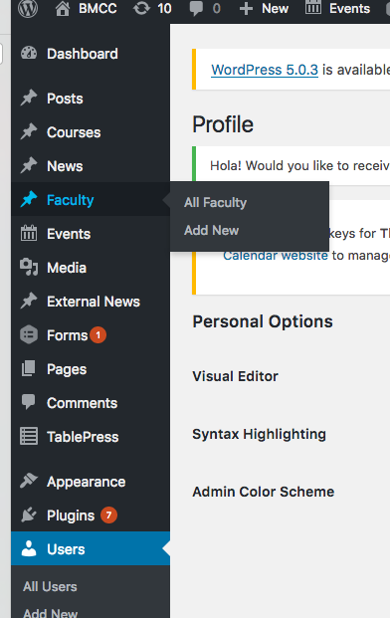

Be consistent. Abbreviate days: Mon., Tue., Wed., Thurs., Fri., Sat., Sun.
5) Editing Your Faculty Page

Type, cut and paste, or edit text in the boxes.

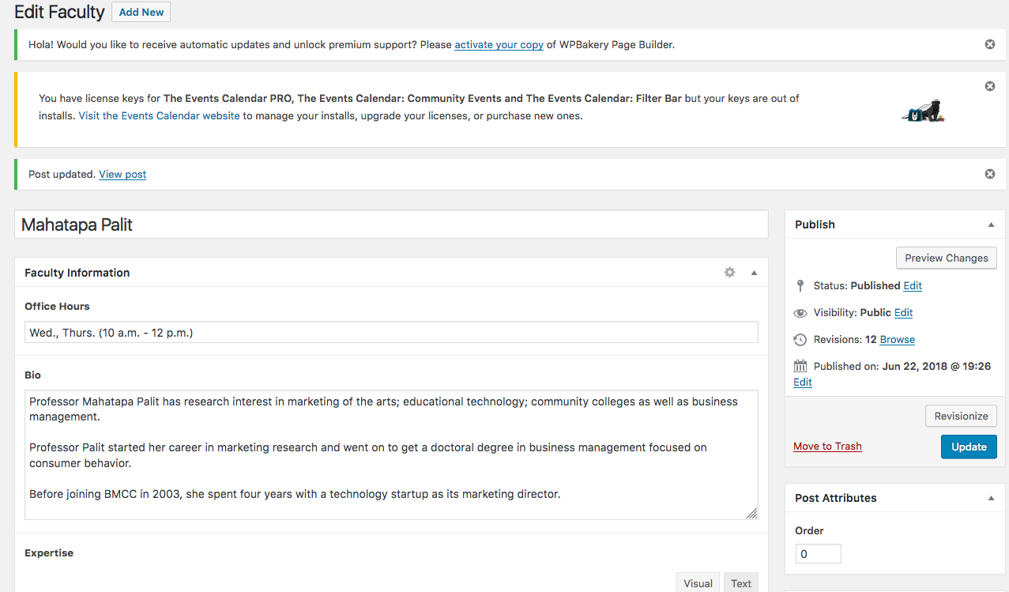

Biographical Description
Use third-person singular to create a brief biographical description. You can include a hyperlink to your Linkedin or personal professional website in the last sentence of your bio.

6) Expertise

Add your areas of expertise.

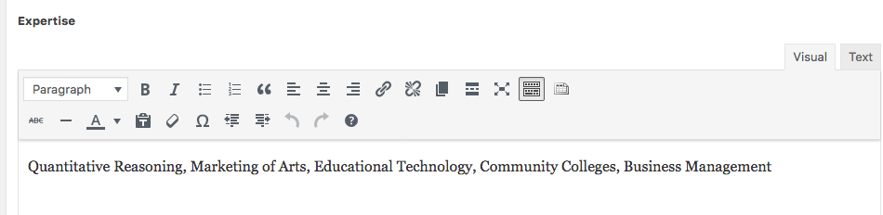

7) Adding Courses Taught

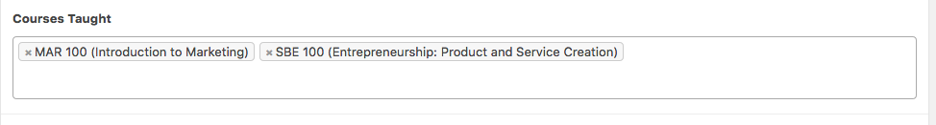

While in the Courses Taught field, type the three letter code for the subject, (ex. MAT, ENG, BUS, etc.) and you will get a drop down list of courses in that field to select from.

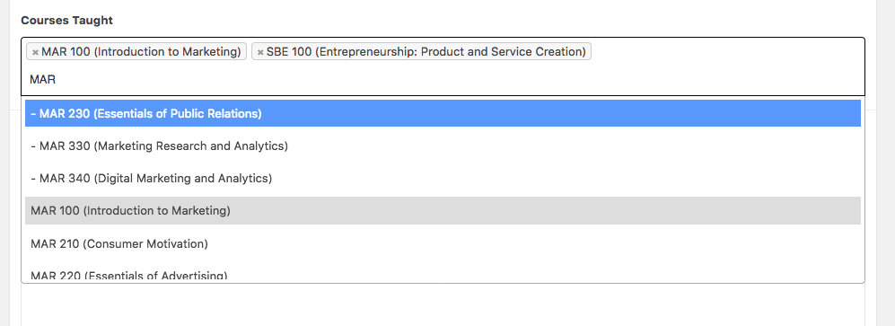

Changing Course Order
You can change the order of the courses by dragging them before or after another course.

8) Adding Publications

Type or cut and paste your publications in the Publications box.

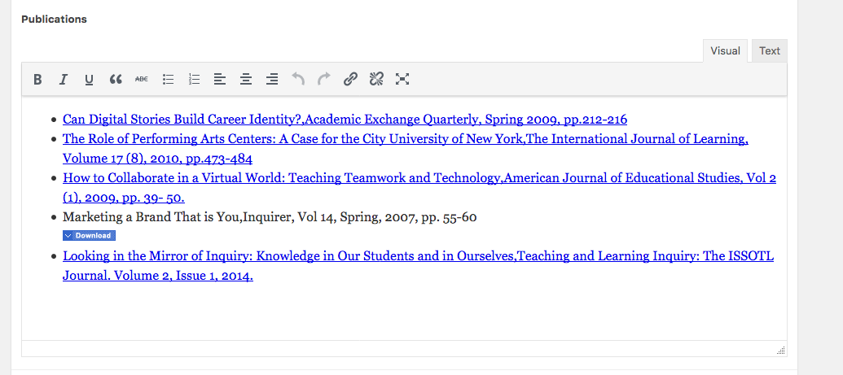

Move the publications (drag and drop or cut and paste) to be in reverse chronological order, so that the newest publication is first)

You can hyperlink to online versions of your publication that are available free of charge.

9) Select Update to save and publish your changes.

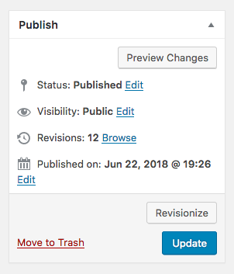
Headshots

Our photographer is available to take headshots of faculty. Please contact Public Affairs by phone (212) 346-8501 or email publicaffairs@bmcc.cuny.edu if you do not have a professional headshot on your faculty page.

You can upload your photo using “Set Featured Image” on the lower right side of the screen.

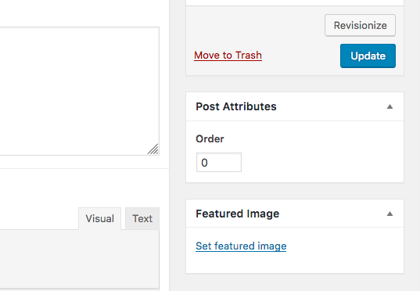

After clicking Set Featured Image, you will be brought to the Media Library. You can select Upload Files and upload your headshot.

Include ALT text

When you upload your headshot or any other image, there will be a chance to add details in the “Attachment Details” box that appears on the right.

Add a description of the image in the “ALT Text” box – either your name if it is an image of you, or a description if it is another kind of image (in another situation.)

The ALT or Alternative text serves two purposes:
- If a computer can’t display the image, the words will appear where the image would to inform the viewer what would be there
- If a sight impaired person is using a screen reading device, the device will read the ALT text to the person, as they cannot see the image.
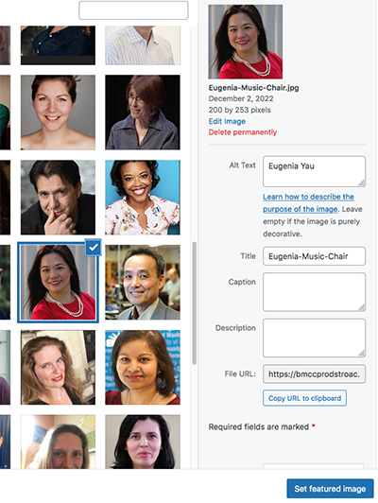

Resume

Scrolling down to the bottom of the page you will find a button to upload a resume or CV.

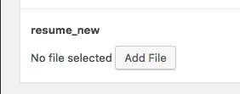

It is recommended that you save your resume as a pdf before uploading it. A pdf can be easily opened by various systems and retain the formatting as intended.

Formatting and Style
AP Style
BMCC uses Associate Press (AP) style for print and website.

Some examples of AP style are:

Time
AP style uses periods for a.m. and p.m. and lower case letters.

Ex. 3:30 p.m. or 8 a.m. is correct

Dates, Months, Years, Days of the Week
For dates and years, use figures. Do not use st, nd, rd, or th with dates

Ex. May 12 is correct . . . not May 12th

Technological Terms
Here are the correct spellings for some common technological terms:
- e-book
- e-book reader
- e-reader
- email
- cellphone
- Facebook

Numbers
Spell out numbers used at the beginning of a sentence, except for years.

Ex. Two hundred students volunteered for the program.
2018 was the year the college president stepped down.

Headings
* Capitalize principal words in headings and subheads
- minor words such as for, of, a, an, at, are not capitalized
- see AP Style Title Case for more information

AP Style References
A more complete summary of the AP style can be found in the following:
- The Purdue Online Writing Lab
- The State of Colorado AP Cheat Sheet

Formatting Style

Use of Bold Type
Use occasional bold type to emphasize one or two words, not a whole sentence or paragraph.

Use of ALL CAPS
This is not a style we use on the BMCC website. It is more difficult to read than mixed case.

Use of Underlining
Underlining is not used on our website, because it can easily be mistaken for a hyperlink

Office of Public Affairs

Website: https://www.bmcc.cuny.edu/about-bmcc/public-affairs/

Main Number: (212) 346-8501
Email: publicaffairs@bmcc.cuny.edu
Location: Room F-1230U, Fiterman Hall
Samantha Ramirez, Office Assistant

Publications
Tom Volpe, Director of Publications
Sharmela Bisram, Graphic Designer
Jeff Wong, Graphic Designer

Marketing
Rosslynn Pieters, Associate Director of Marketing
Louis Chan, Photographer/Social Media
David Pangburn, Videographer

Public Relations
Lynn McGee, Communications Manager
John Cody Lyon, Writer

Web and Multimedia
Cynthia Blayer, Web Content Manager
Rob Gizis, Graphic and Multimedia Design

